|  |  |  |  |  |
| --- | --- | --- | --- | --- |
| **National University of Computer and Emerging Sciences, Lahore Campus** | | | | |
| C:\Users\saif\AppData\Local\Microsoft\Windows\Temporary Internet Files\Content.Word\final design.jpg | **Course Name:** | **Database Systems** | **Course Code:** | **CS2005** |
| **Degree Program:** | **BS(Computer Science)** | **Semester:** | **Fall 2021** |
| **Exam Duration:** | **3 Hours** | **Total Marks:** | **100** |
| **Paper Date:** | **Wed 12-Jan-2022** | **Weight** | **45%** |
| **Section:** | **ALL** | **Page(s):** | **10** |
| **Exam Type:** | **Final Exam** | **Total Questions:** | **8** |

|  |
| --- |
| **Student : Name:_____________________________ Roll No.________________ Section:_______** |

|  |  |
| --- | --- |
| **Instruction/Notes:** | Scratch sheet can be used for rough work however, all the questions and steps are to be shown on question paper. ***No extra/rough sheets should be submitted with question paper***.  You will not get any credit if you do not show proper working, reasoning and steps as asked in question statements. |

**Q1.** *(5 points)* Consider the following schedule of three transactions T1, T2, and T3.

**S:**  r1(A), r2(C), r3(C), w2(C), r3(B), r1(B), w2(B), c3, c1, c2.

Draw the serializability (precedence) graph for this schedule. State whether this schedule is (conflict) serializable or not. If the schedule is serializable, write down the equivalent serial schedule(s) otherwise explain why it is not.

**Ans:**

**No loop in graph. It is conflict serializable.  
Serial schedule: T1, T3, T2 or T3, T1, T2**

**Q2.** *(5+5= 10 points)* Find all possible keys and the minimal cover for the following:

1. *R (A, B, C, D, E, F)*, with FDs *F = {AB→CD, B→EF, A→B, A→D}*. Show each step.
2. *R (A, B, C, D, E, F, G, H)*, with FDs *F = {A→ABCDEFGH, BCD→ABCDEFGH, G→H}*. Show each step.

**Ans:**

**a) Key is {A}. Fc = {A→BCD, B→EF}**

**b) Keys are {A} & {BCD}. Fc = {A→BCD, BCD→AEFG, G→H}**

**Q3.** *(5+5=10 points)* Given the relation *R (A, B, C, D)*, find the highest normal form with respect to the following FDs and Keys (each part is separate). If *R* is not in *BCNF*, decompose it into a set of BCNF relations. Indicate which dependencies if any are not preserved by the decomposition.

**a.** *F = {AB → C, C → D, and D → A}*. Suppose keys are *{AB}*, *{BC}*, and *{BD}*.

**b.** *F = {A → B, B → C, C → D, D → A}*. Suppose keys are *{A}*, *{B}*, *{C}*, and *{D}*.

**Ans:**

**a) HNF=3NF, BCNF schema: R1(BC), R2(CD), R3(DA) FD1: AB→C is lost.**

**b) Already in BCNF.**

**Q4.** *(10 points)* Prove or disprove the following inference rules for functional dependencies.

**a.** {AB → C, C → D} ⇒ A → D

**b.** {A → B, AB → C} ⇒ A → C

**c.** {A → B, A → D, BD → C} ⇒ A → C

**d.** {A → BC, C → D} ⇒ AB → D

**e.** {A → EF, F → CD, D → B} ⇒ A → BC

**Ans:**

**a) Disproved and (b,c,d,e) Proved.**

**Q5.** *(10 points)* Consider the following database that represents, books, publishers, and books published by publishers.

|  |  |  |  |  |  |  |  |  |  |  |  |  |  |  |  |  |  |  |  |  |  |  |  |  |  |  |  |  |  |  |  |  |  |  |  |  |  |  |  |  |  |  |  |  |  |  |  |  |  |  |  |  |  |  |  |  |  |  |  |  |
| --- | --- | --- | --- | --- | --- | --- | --- | --- | --- | --- | --- | --- | --- | --- | --- | --- | --- | --- | --- | --- | --- | --- | --- | --- | --- | --- | --- | --- | --- | --- | --- | --- | --- | --- | --- | --- | --- | --- | --- | --- | --- | --- | --- | --- | --- | --- | --- | --- | --- | --- | --- | --- | --- | --- | --- | --- | --- | --- | --- | --- |
| |  |  |  | | --- | --- | --- | | **Books** | | | | **BNo** | **Title** | **Author** | | 303 | Data Warehousing | Paulraj | | 909 | Database Systems | Elmasri | | 202 | Data Structures | Lafore | | 101 | Database Systems | Raghu | | 505 | Algorithms | Cormen | |  | |  |  |  | | --- | --- | --- | | **Publishers** | | | | **PNo** | **Publisher** | **City** | | 1 | Wiley | New Jersey | | 2 | Pearson | New Jersey | | 3 | McGraw-Hill | New York | | 4 | Elsevier | Amsterdam | | |  |  |  | | --- | --- | --- | | **Publishes** | | | | **PNo** | **BNo** | **Pages** | | 1 | 303 | 571 | | 2 | 909 | 1242 | | 2 | 202 | 776 | | 3 | 101 | 1065 | |

Write the result of the following queries for the Database State given above. Also, show the intermediate tables.

1. R1 ← **Π** BNo (Books) – ((**Π** BNo (Books) – **Π** BNo (Publishes))

Result ← Books ⟖ Books.BNo=R1.BNo R1

1. SELECT * FROM books B WHERE NOT EXISTS (SELECT * FROM publishers P JOIN publishes S ON P.PNo=S.PNo

WHERE city != ‘New York’ AND B.BNo=S.BNo);

**Ans:**

**a)**

**R1 Result**

|  |  |  |
| --- | --- | --- |
| **BNo** | **Title** | **Author** |
| 303 | Data Warehousing | Paulraj |
| 909 | Database Systems | Elmasri |
| 202 | Data Structures | Lafore |
| 101 | Database Systems | Raghu |

|  |
| --- |
| **BNo** |
| 303 |
| 909 |
| 202 |
| 101 |

**b)**

|  |  |  |
| --- | --- | --- |
| **BNo** | **Title** | **Author** |
| 101 | Database Systems | Raghu |
| 505 | Algorithms | Cormen |

**Q6.** *(30 points)* Consider the above database, write both **SQL and Relation Algebra Queries** for the following tasks:

1. Print the title and author of the book that has the most number of pages.
2. Print all of the publishers that are in a city with two or more publishers.
3. Print all books that have the same title but different authors.

**Ans:**

**a) select title, author from books join publishes on books.bno=publishes.bno**

**where pages = (select max(pages) from publishes);**

**b) select publisher from publishers where city in (select city from publishers group by city having count(city) >= 2);**

**c) select * from books as b1 join books as b2 on b1.title=b2.title and b1.author != b2.author;**

**Q7.** *(10 points)* Map the following ER/EER Diagram into a relational model and specify all constraints.

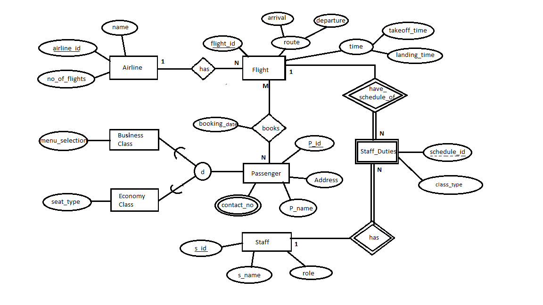

**Ans:**

**Airline**

Attributes: airline_id (pk), name, no_of_flights

**Flight**

Attributes: flight_id (pk), takeoff_time, landing_time, arrival, departure, airline_id (fk Airline)

**Staff Duties**

Attributes: schedule_id (pk), flight_id (pk,fk Flight), staff_id (pk,fk Staff), class_type

**Staff**

Attributes: s_id (pk), s_name, role

**Bookings**

Attributes: booking_date , p_id (pk, fk passenger), flight_id (pk, fk Flight)

**Passenger**

Attributes: p_id (pk), p_name, address

**Passenger Contact**

Attributes: p_id (pk, fk passenger), contact_no (pk)

**Economy Class**

Attributes: p_id (pk, fk passenger), menu_selection

**Business Class**

Attributes: p_id (pk, fk fk passenger), seat_type

**Q8.** *(15 points)* Suppose that you are working as a database designer, and in that role you are assigned a task to develop an ER/EER diagram for the following scenario. A Software company (name, business id, no of employees) has employees. Company has several information of employees i.e. employee id, employee name, Contact number (An employee can have multiple contact numbers), address that contains house no, town and city. Employees are divided into two categories i.e. developer and manager. A developer has expert technology, years of experience. A manager has area of expertise, years of experience and no of projects done so far. A manager can only lead the project and help developers in technical problems, he is not allowed to develop. A developer develops the project. Multiple developers develop multiple projects. One manager is allowed to lead one project. A manger can lead multiple projects at time. A project has specific project id, name, start date and cost. A project can be a mobile app (language used, platform, tool), web app (language used, tool) or any other kind. Demonstrator is the one who demonstrates the project. A demonstrate can be a manger or a developer.

Draw an ER/EER diagram (using notation discussed in lectures) for the above scenario. Specify all constraints that should hold on the database and state any assumptions you make.

**Ans:**

